**Locking and Security**

Neal Traynor - nealtraynor@cmail.carleton.ca

For locking and Security I looked at 3 engineering principles: Durability, simplicity, and effectiveness. **Durability** concerns how well the mechanism can withstand impact, and how likely the chances are that it will break. **Simplicity** Concerns how many moving parts there are, and ultimately, how easily the mechanism can be made and assembled. **Effectiveness** concerns how well the design will work in the end.

The locking design for the vehicle needed to prevent against two main things. First it had to prevent the possibility of someone gaining access inside the vehicle. Secondly it had to prevent the possibility of the vehicle being wheeled or carried away by someone/a group of people. As a result a two-tier approach was made in the design for the security of the vehicle. First of all, the primary approach was to incorporate the existing car door lock into the door of our vehicle. This would prevent anyone from gaining access inside the vehicle. The secondary approach was to use the common bike lock, which would lock the vehicle to a pole, or a bike rack. This would prevent the bike from getting wheeled or carried away.

**Primary Option:**

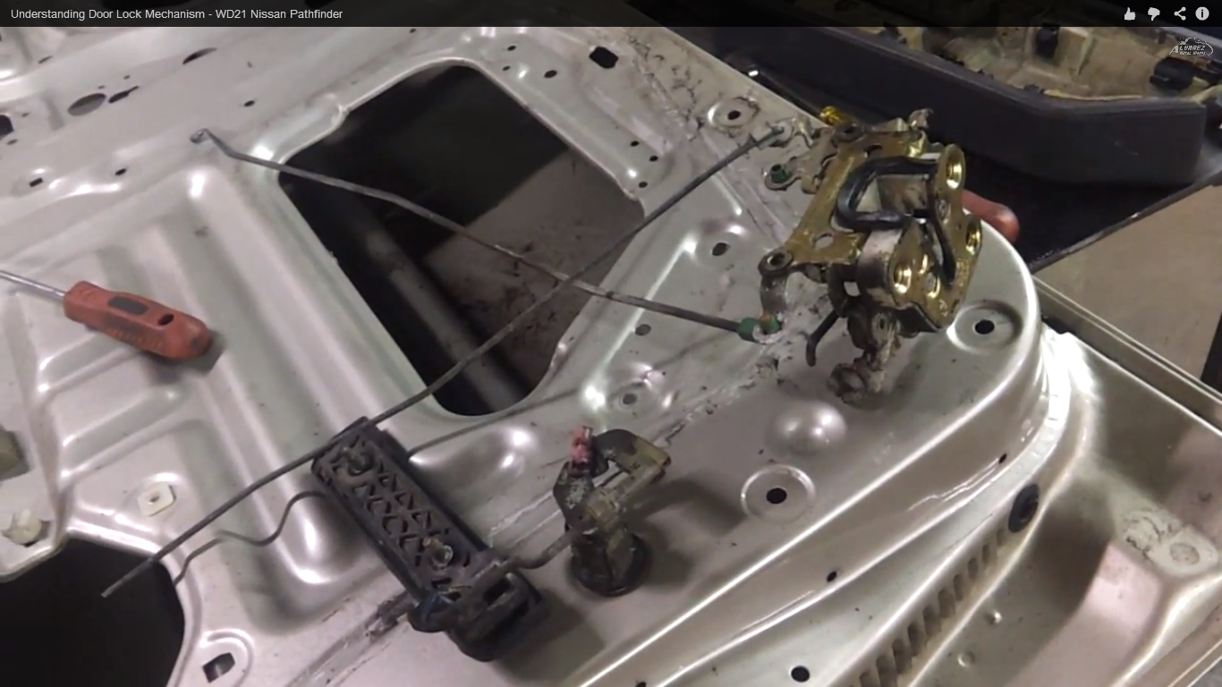

Figure 1: This is a common locking mechanism in a vehicle. The part shown is the female part.

Incorporating the already existing car door lock into our vehicle tackles all three engineering principles that I defined above. Figure 1 shows a common locking mechanism in a standard vehicle. Due to the uniqueness of the vehicle that is being designed in class, some modifications will have to be made. For instance, the two connecting wires can be shortened greatly, since our locking mechanism will be centralized in a small area. Also, in a standard car door lock the female part of the mechanism is on the door itself, with the male part on the shell or frame of the vehicle. In our design, this will be reversed. This is because the bulk of the weight is in the female part, and having this fixed to the frame of the vehicle will have the least amount of disturbance to the force distribution that Jacob is working on.

**Secondary Option:**

Due to the extreme light weight of the overall design, the vehicle could easily be picked up by a group of people and carried off, or wheeled away by one person. As a result, it is necessary to make sure the vehicle is attached to a fixed object. This can be done by using a standard bike lock, and attaching it to either a pole, or a bike rack. The major problem with this, however, is the availability of a fixed object such as a pole or a bike rack, especially one by the side of the road. In order for this locking option to become feasible, bike racks would need to be installed specifically for our vehicle.